**Web-Development_BOOTCAMP - UDEMY**

**SECTION 1 : Front-End Web-Development**

#### Install Visual Studio Code Extensions:

* [Live Preview](https://marketplace.visualstudio.com/items?itemName=ms-vscode.live-server" \t "https://www.udemy.com/course/the-complete-web-development-bootcamp/learn/lecture/_blank)
* [Prettier](https://marketplace.visualstudio.com/items?itemName=esbenp.prettier-vscode" \t "https://www.udemy.com/course/the-complete-web-development-bootcamp/learn/lecture/_blank)
* [vscode-icons](https://marketplace.visualstudio.com/items?itemName=vscode-icons-team.vscode-icons" \t "https://www.udemy.com/course/the-complete-web-development-bootcamp/learn/lecture/_blank)

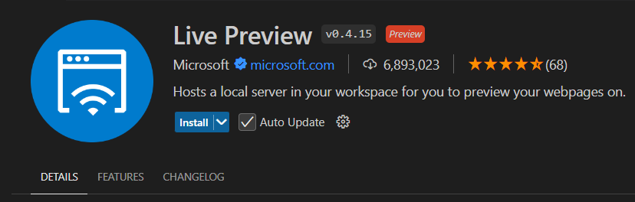

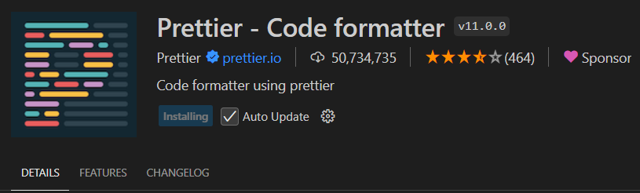

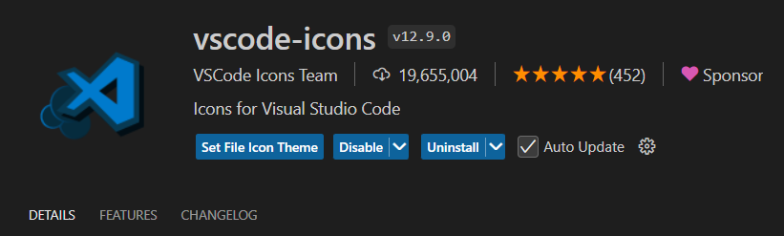

#### How do websites Work ?

